**Shopper’s Login:**

* When a user opens the browser enters the URL(https://www.shoppersstack.com/), the welcome page will be displayed. And if the user wants to log in or create a new account
* Users Have to click on login, they will get 3 different modules: Shopper login, Merchant login & Admin login.

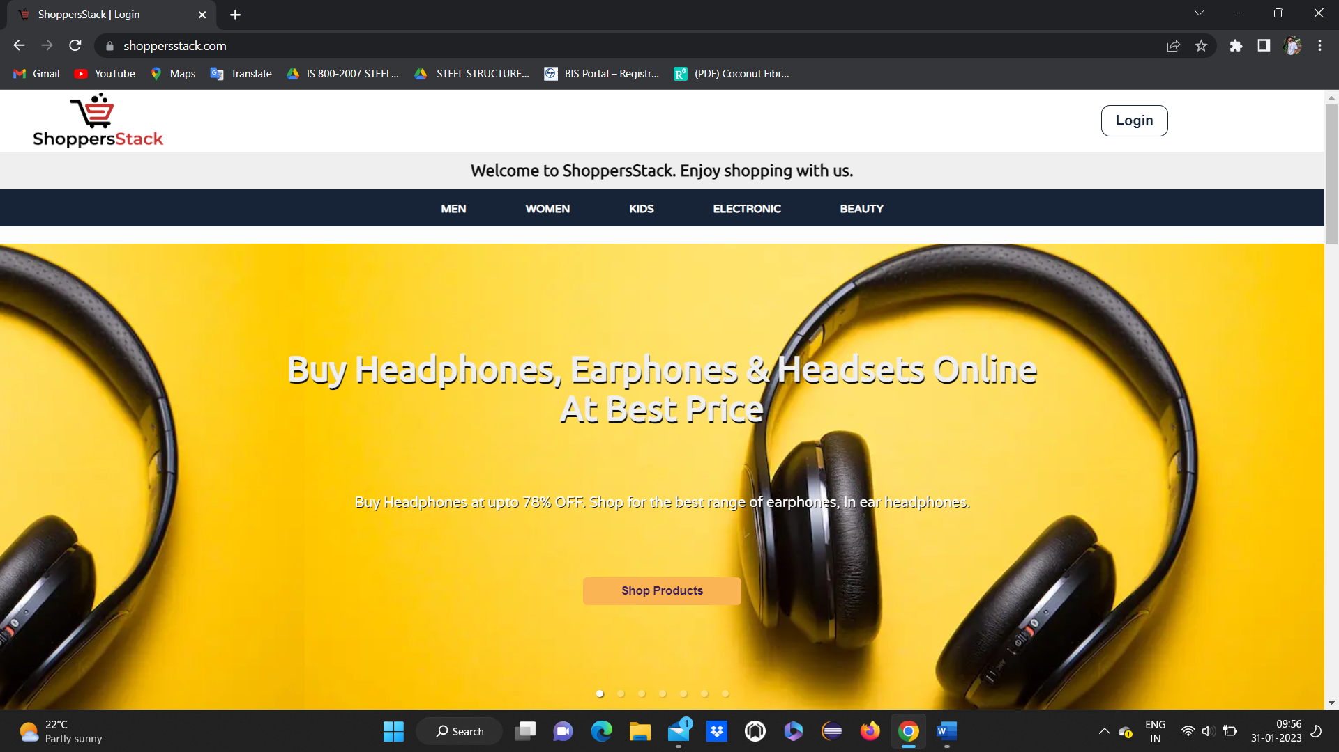

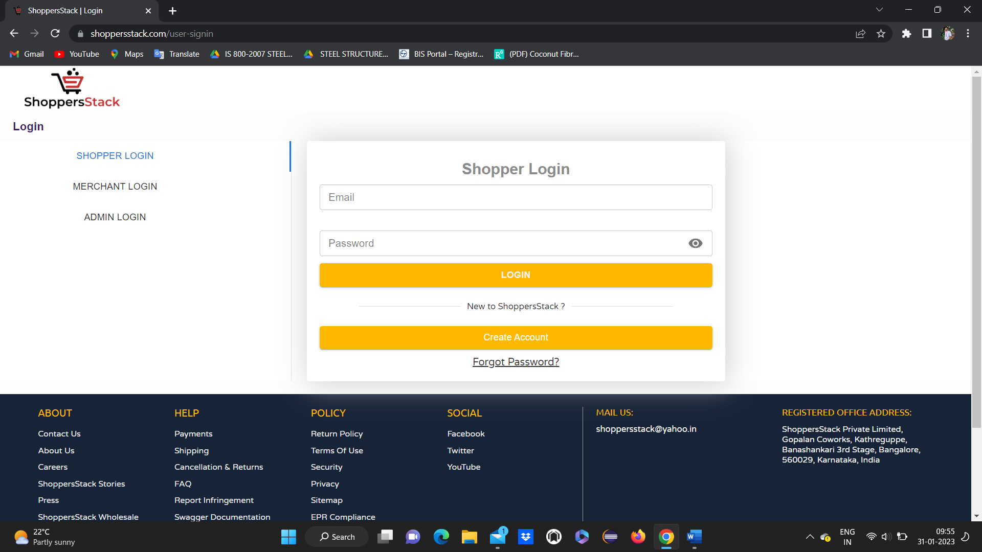

* No need to Click on shopper login by default it will select shoppers login
* Provides shoppers login page

Should have functionalities like email, password, login, create account and forgot password

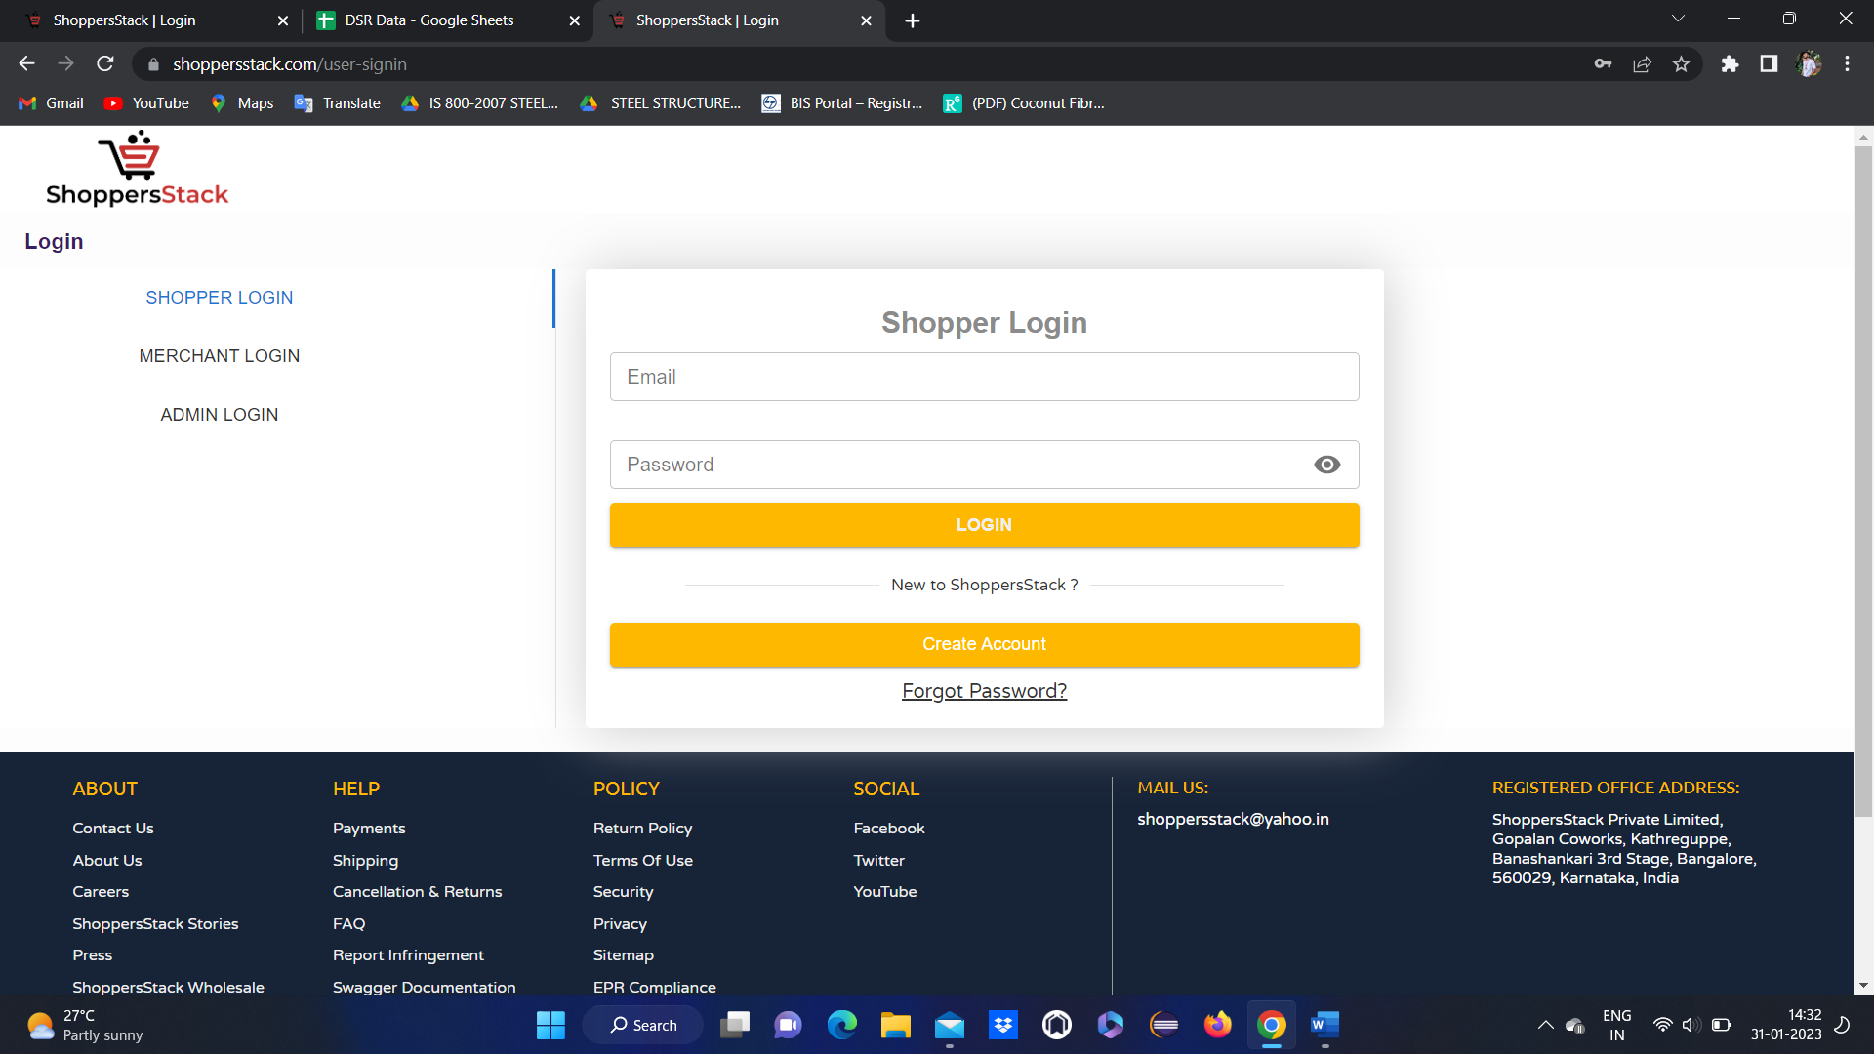

* First user has to create an account .
* (without creating account user is not able to use account).
* click on Create account button
* Create your profile page will be displayed. Here the user has to fill in all the MANDATORY FIELDS and has to click on the Register button.

 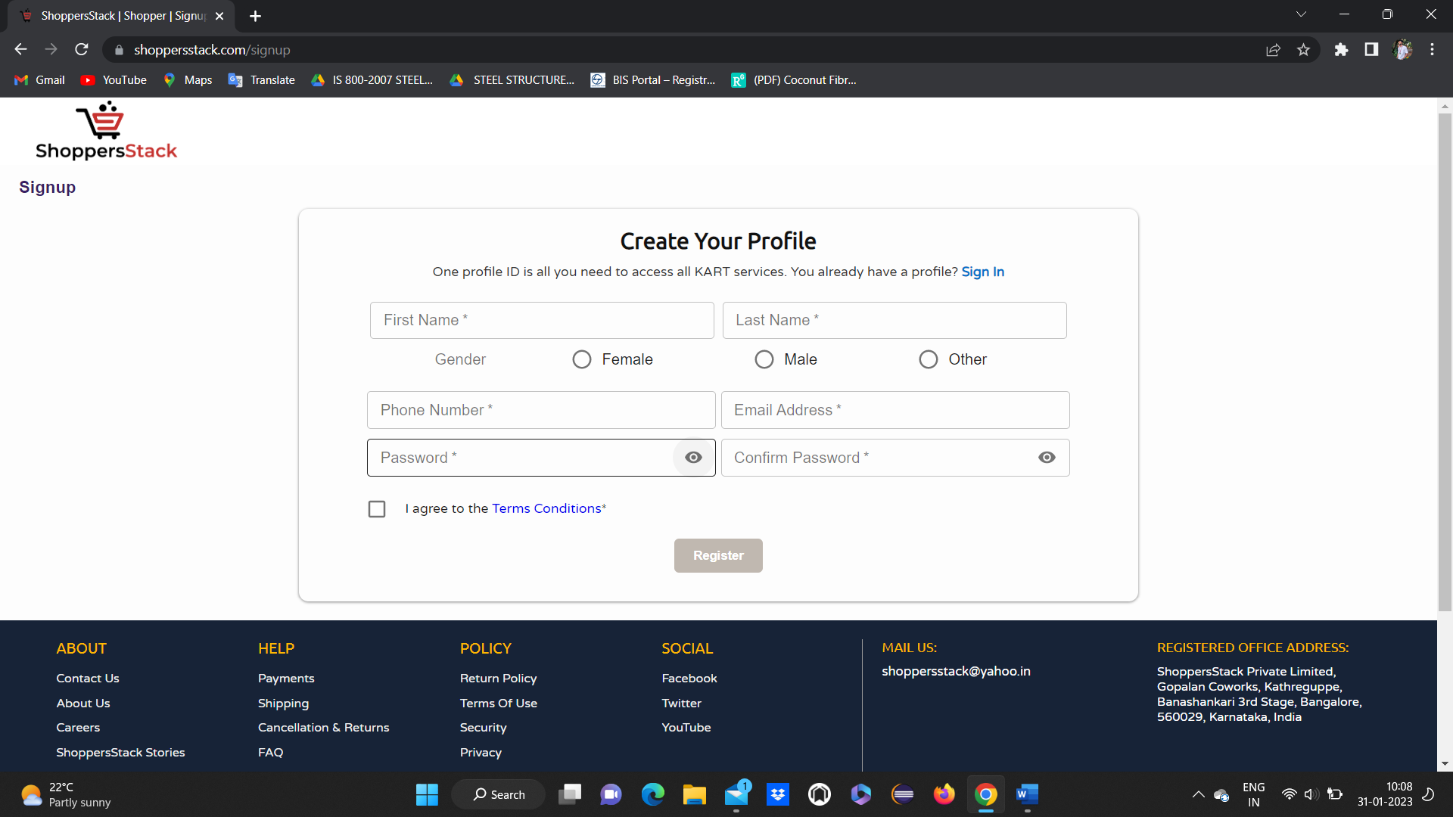

* After entering all the valid details, when the user clicks on the register, user will be registered Successfully and home page will be displayed with confirmation message stating successfully registered.

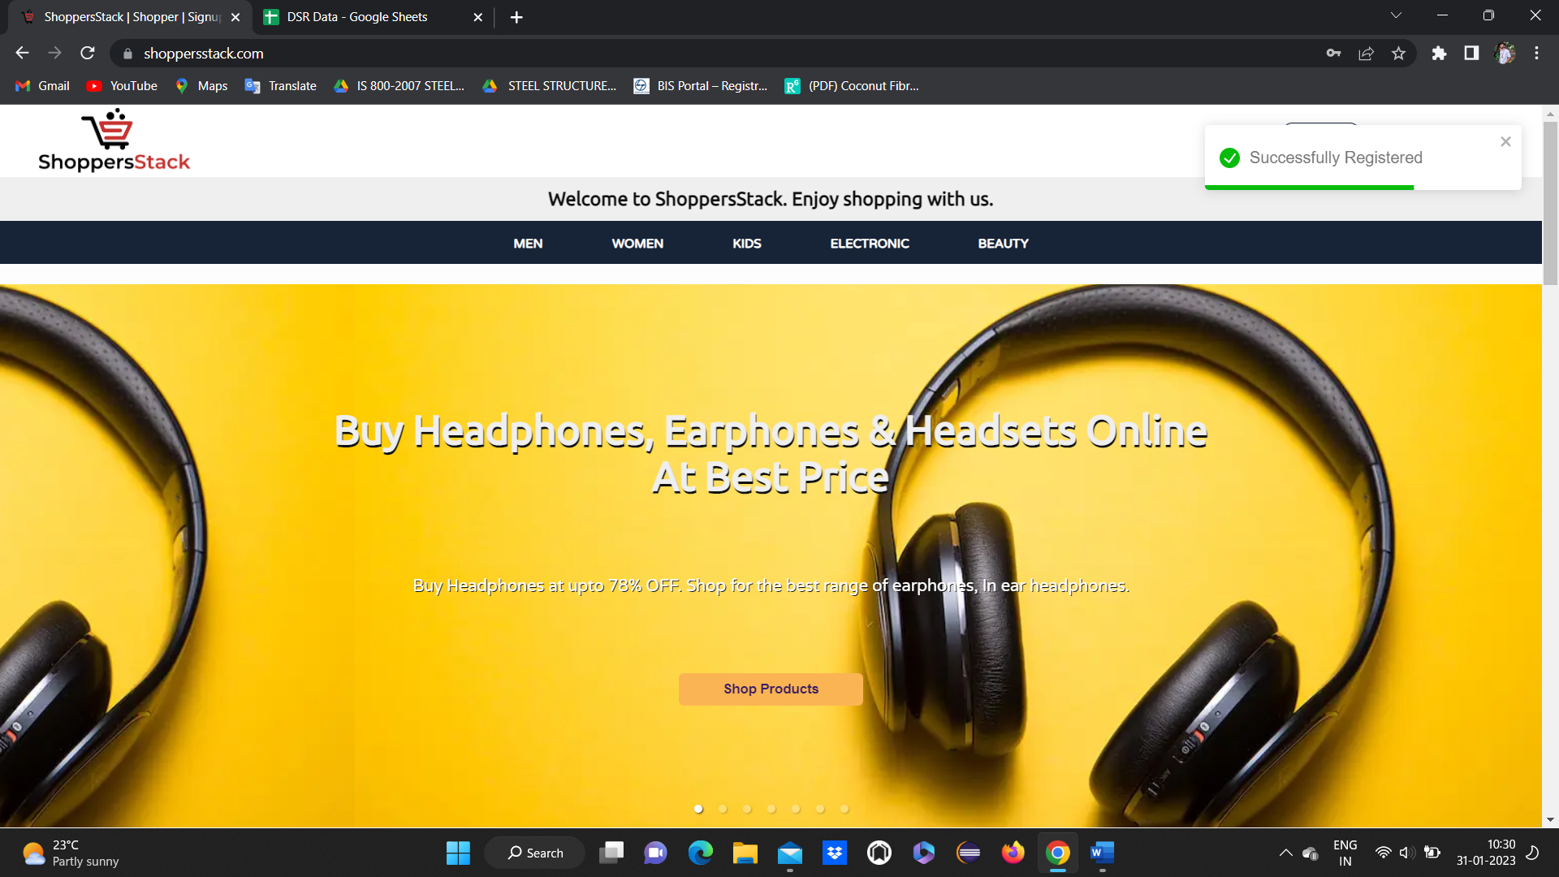

* When user wants log in to his account, he has to click on log in button, login page will be displayed

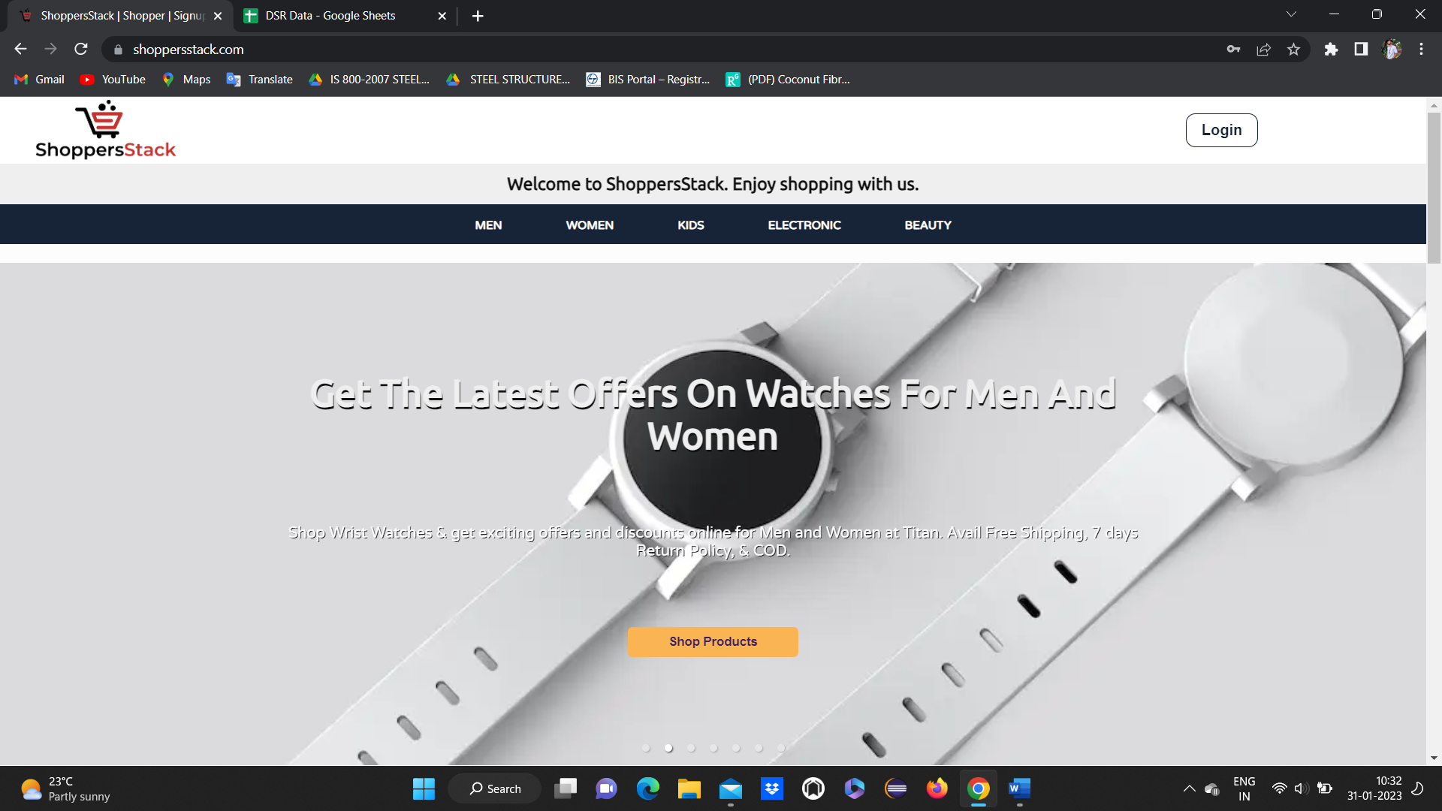

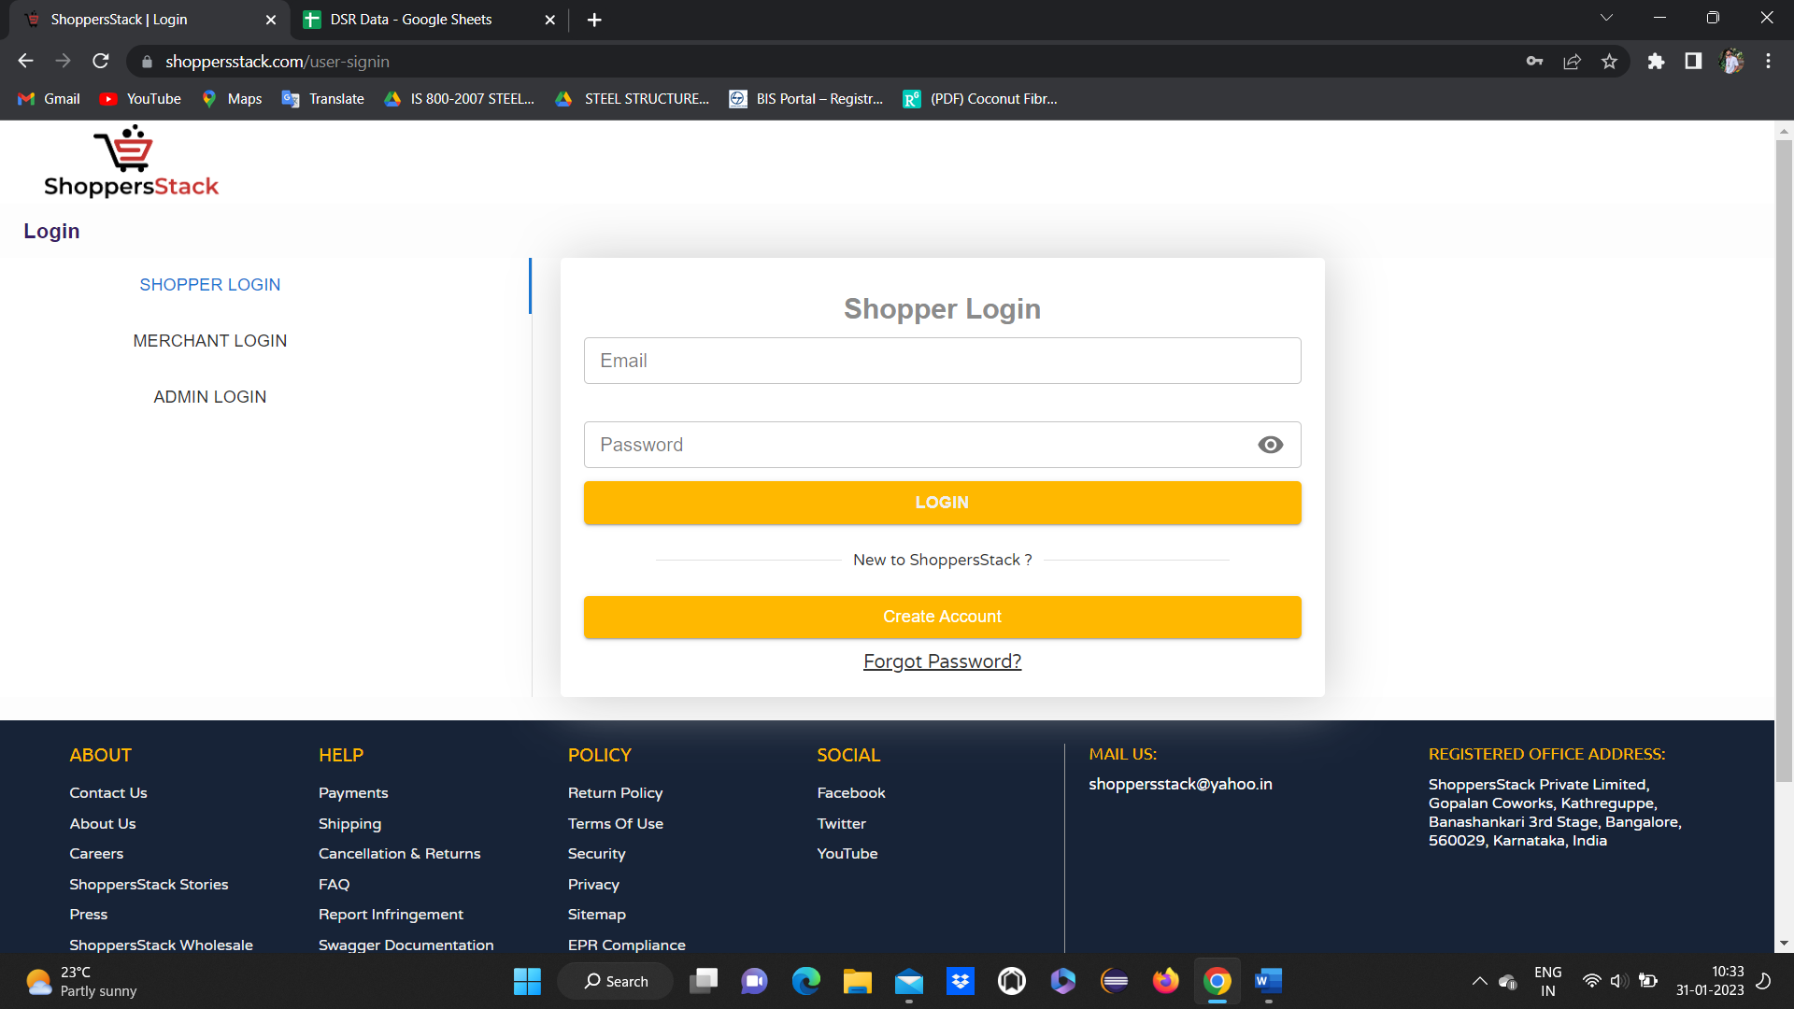

* After entering registered email address and password and click on login user home page should be displayed
* If user forgot the password means he can change the password



* Forgot password page will display

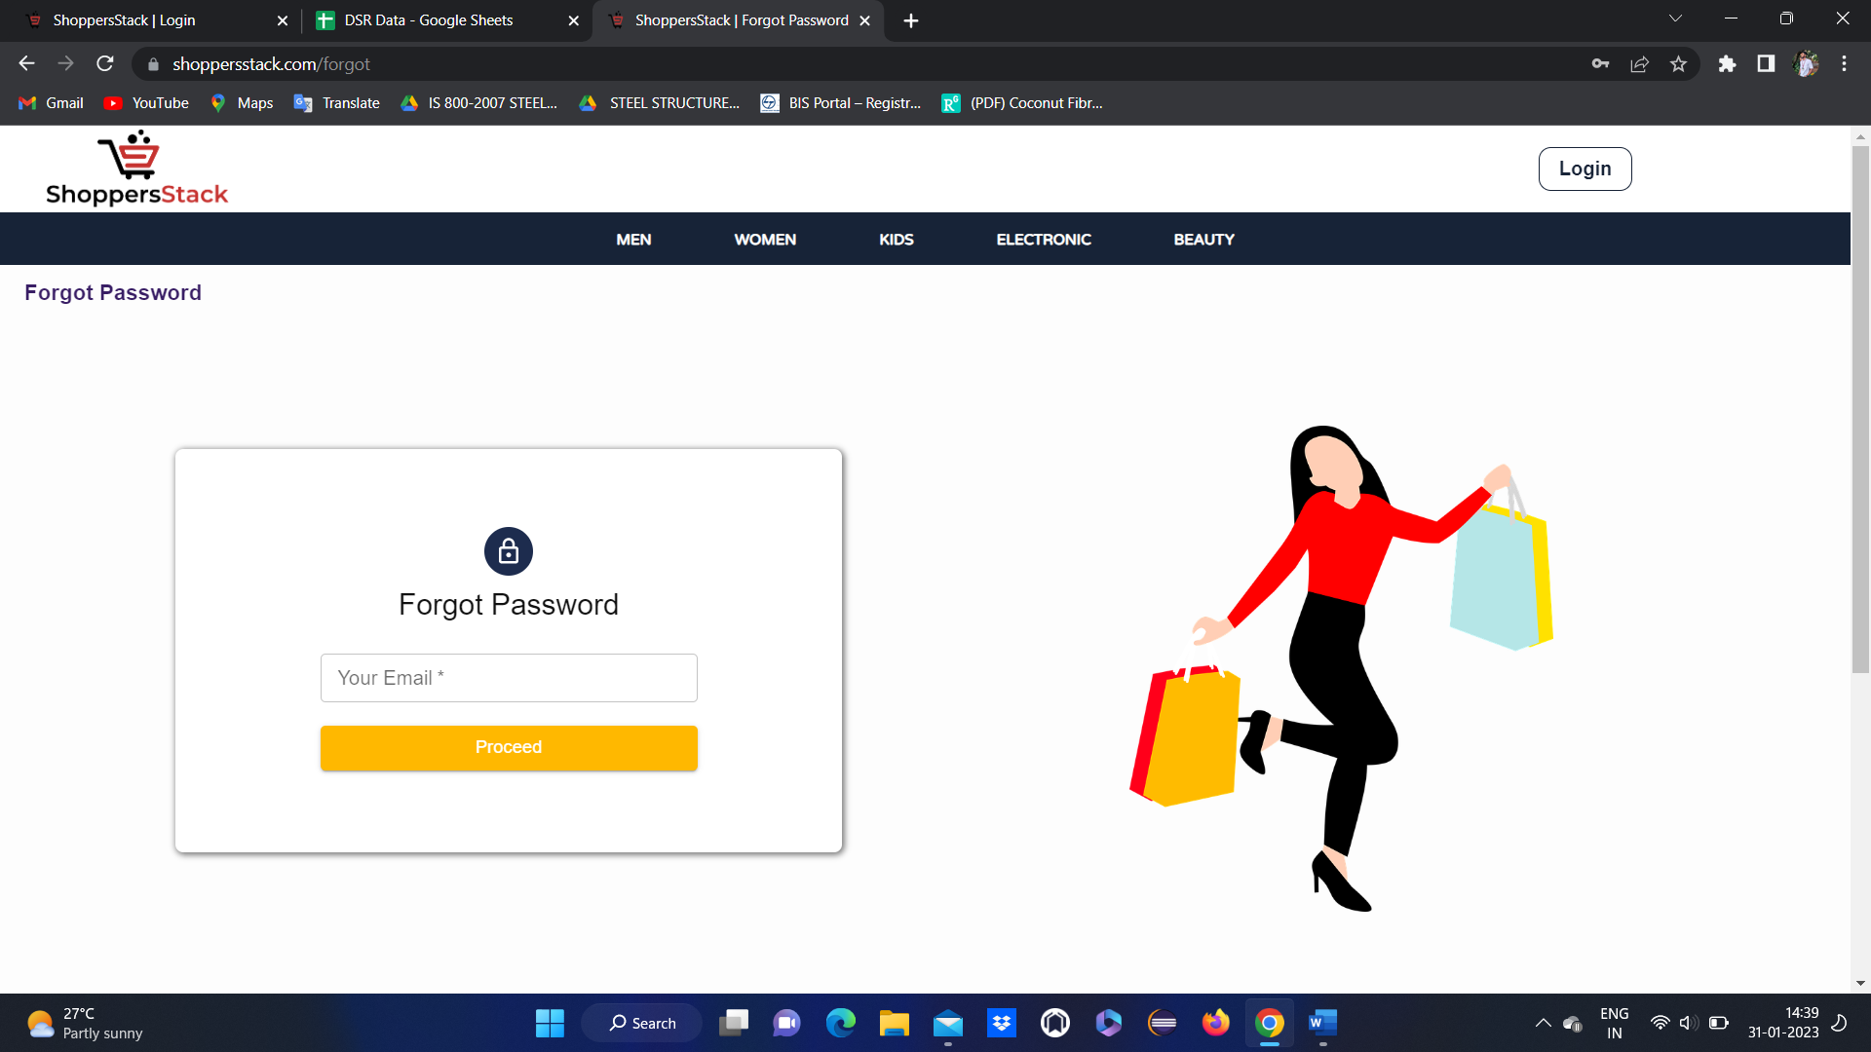

* Enter mail id and click proceed
* User will receive a password change link for entered email id
* Click on the link Reset password page will display --🡪change password

**Merchant’s Login:**

* When a user opens the browser enters the URL(https://www.shoppersstack.com/), the welcome page will be displayed.
* And if the user wants to log in or create a new account user has to click on login, they will get 3 different modules: Shopper login, Merchant login & Admin login.





* Click on Merchant Login

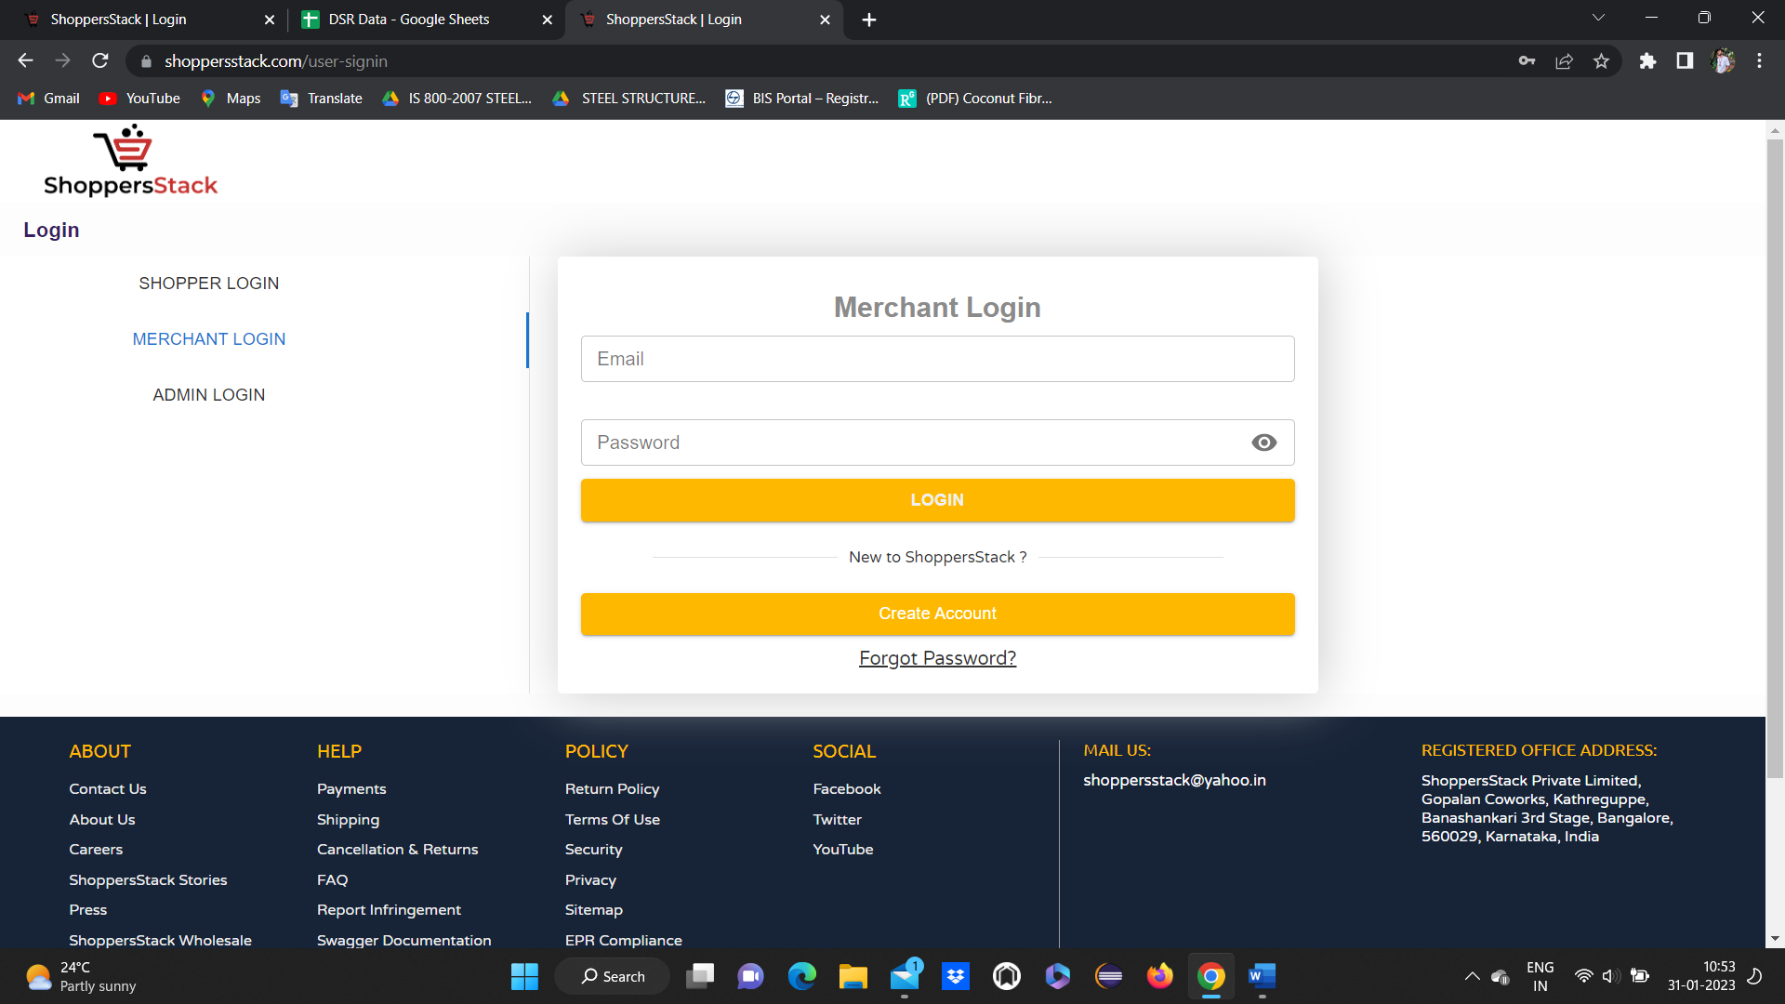

* Click on create account button,



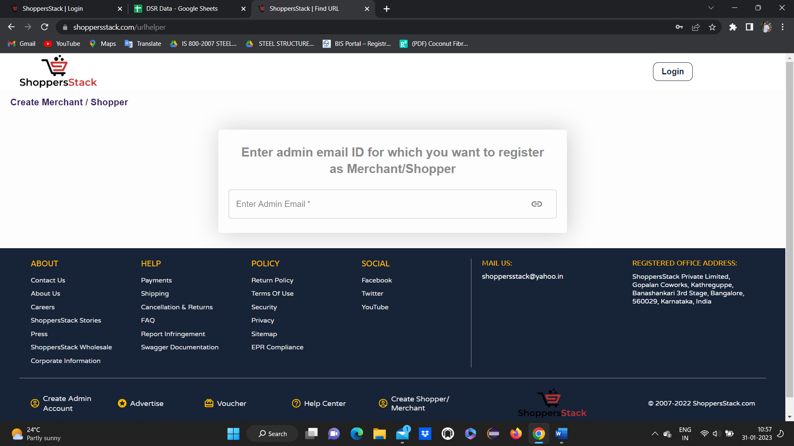

* Enter the admin Email ID into this text field and click on the link
* It displays shoppers signup and merchant signup

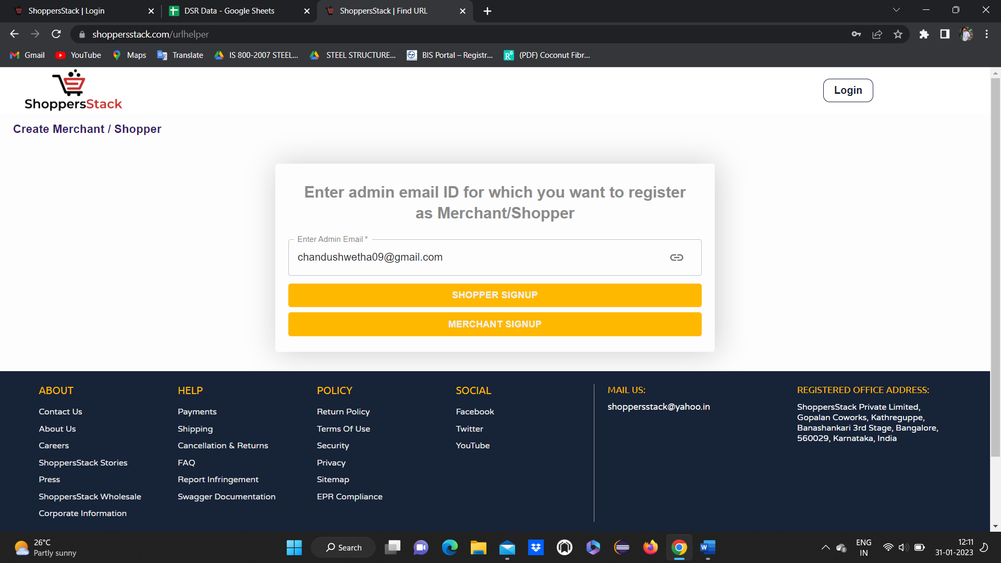

* Click on the merchant signup button, merchant signup page should display.

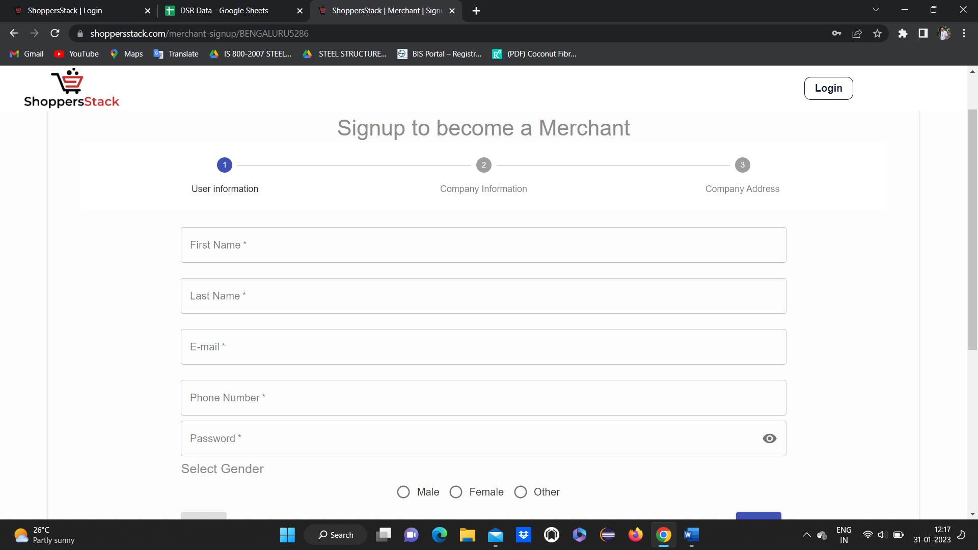

* Merchant page should display with user information , company information , company address
* Fill data for all the functionalities in user information page and click on next button.
* It will go to company information page

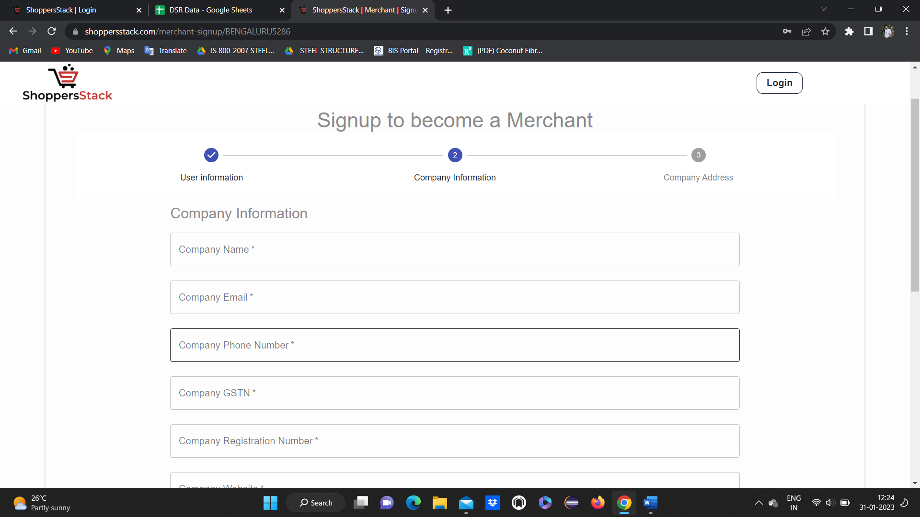

* Fill data for all the functionalities in company information page and click on next button.
* It will go to company Address page.

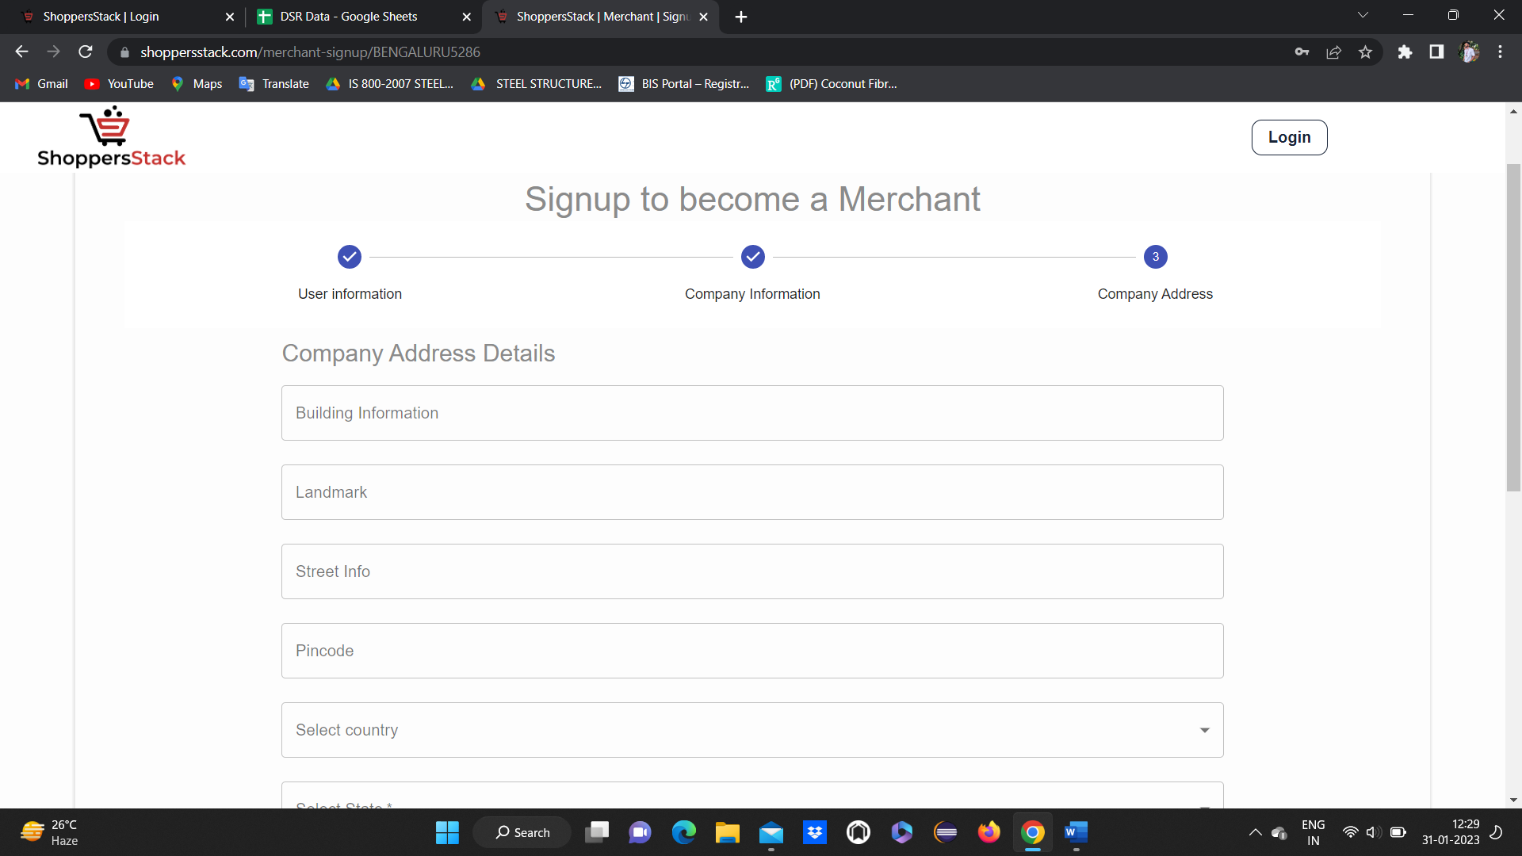

* Fill data for all the functionalities in company Address page and click on terms and condition .
* terms and condition page will display and check I agree to the Terms Conditions

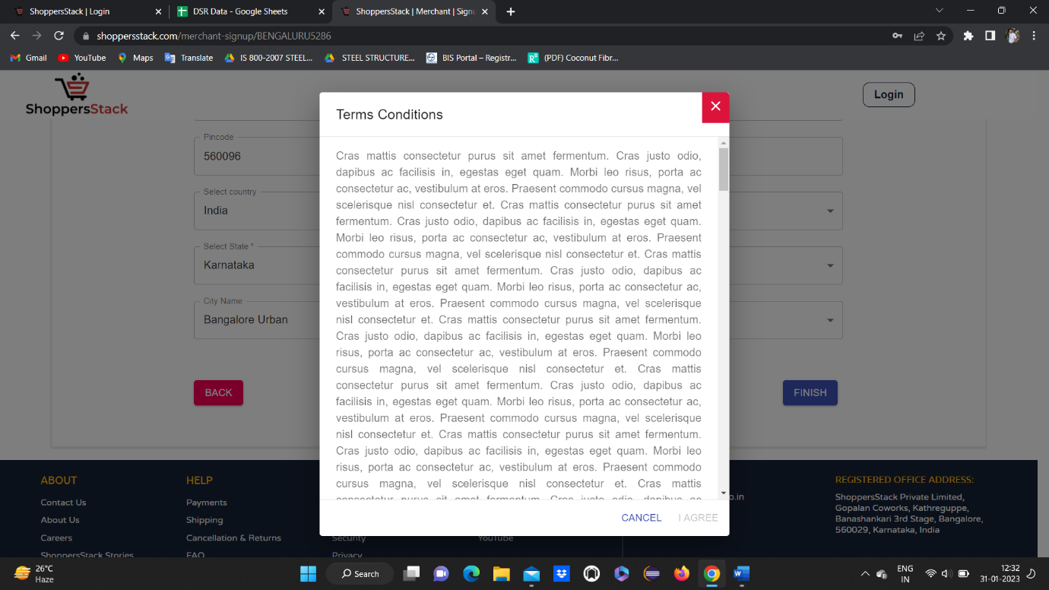

click on I agree

click on finish

After filling in all the details, the merchant clicks on the finish button, showing that the user merchant ID is created.

Go back and click on login and click on merchant login



After login

Merchant page will display

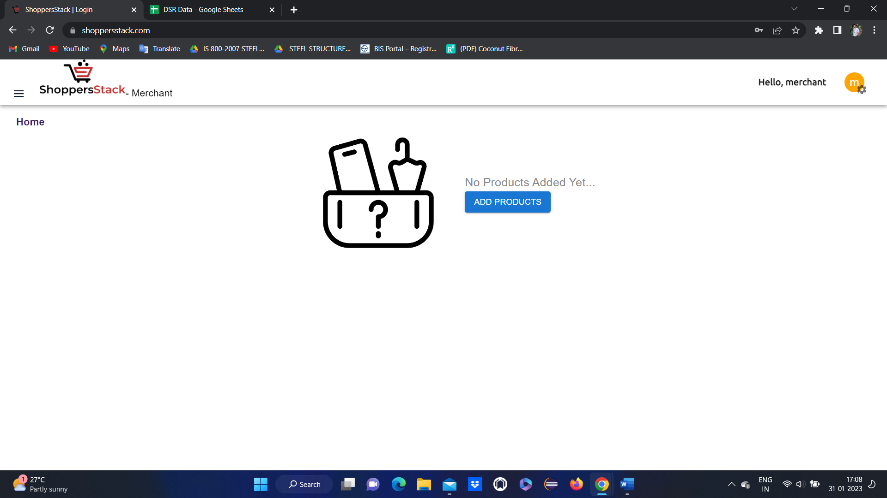

Merchant wants to add product 🡪

When user clicks on add products 🡪add products page will display

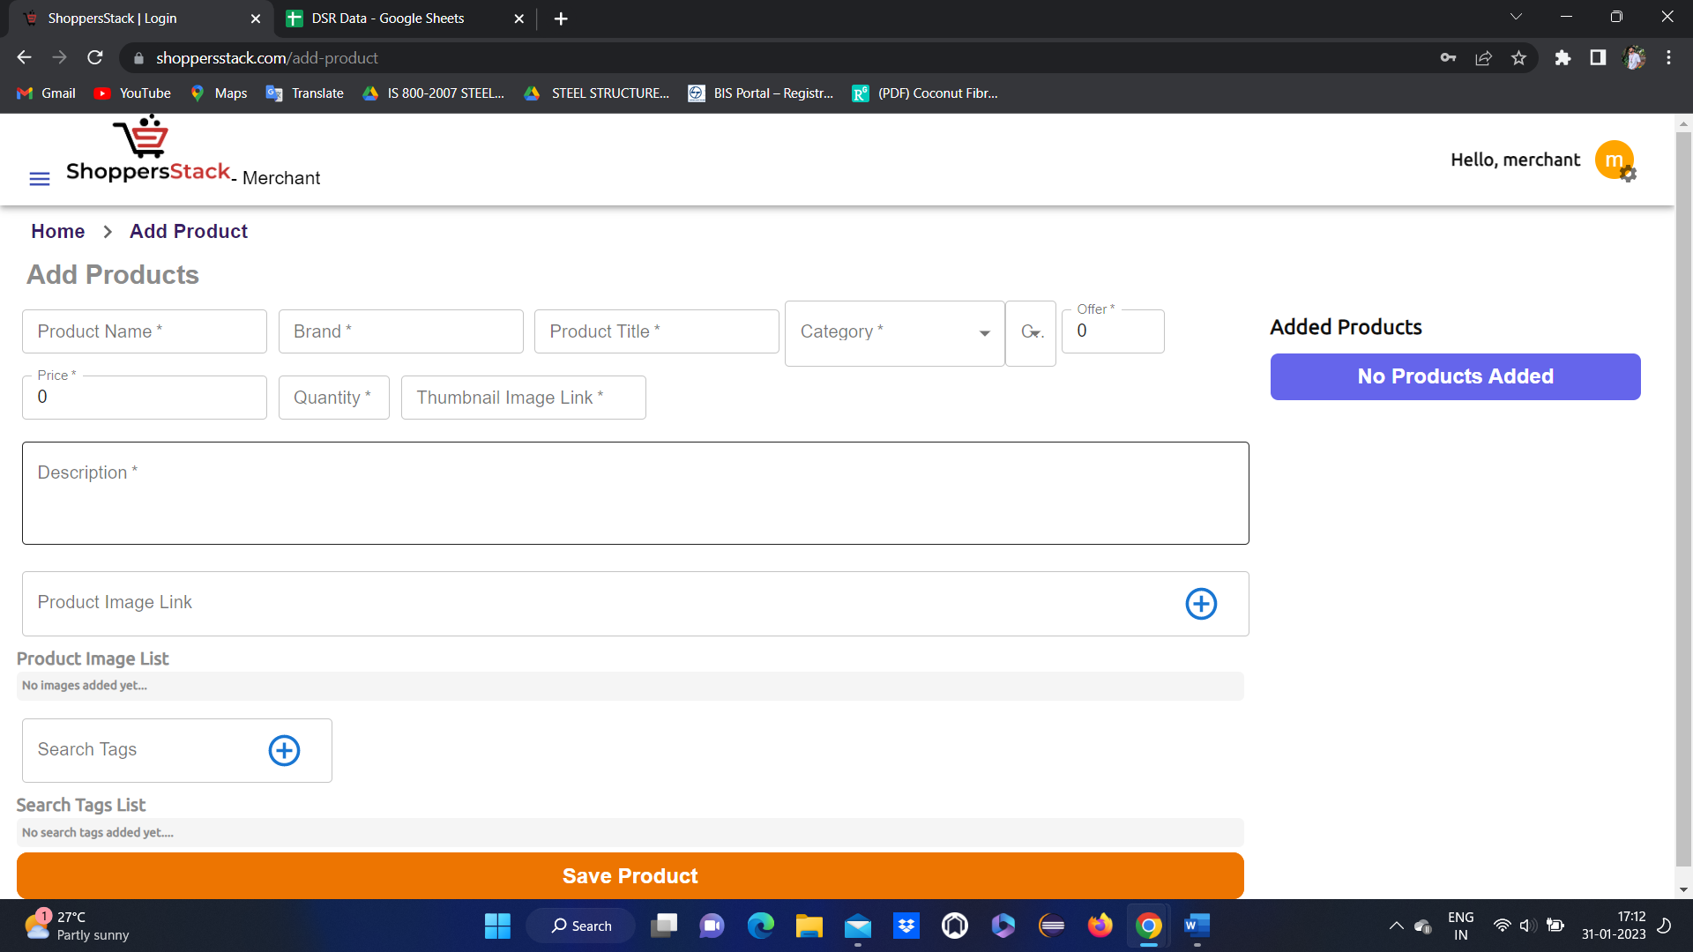

After entering data for all fields and click on save product . product will be saved and displayed

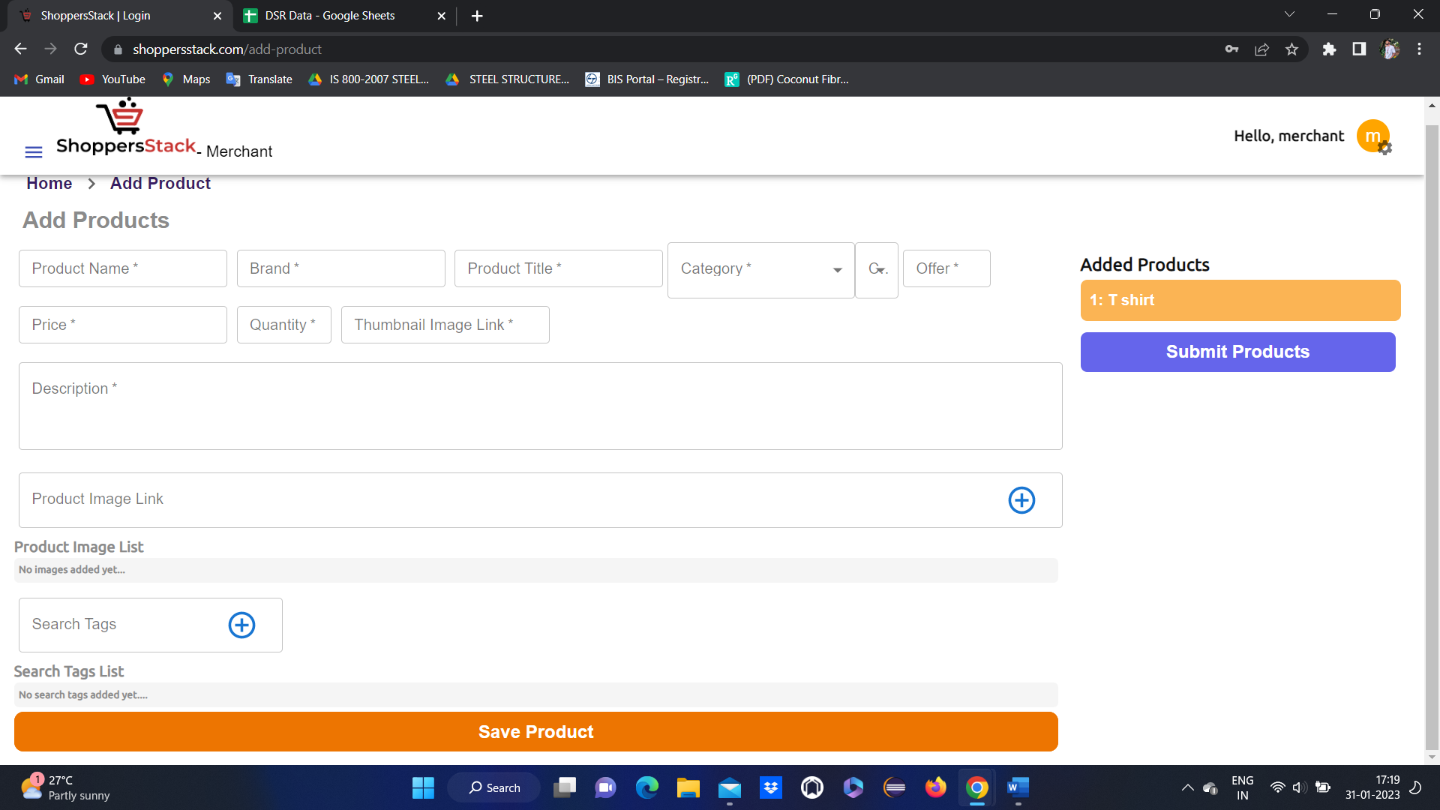

Click on submit products

After submitting the product confirmation message stating **product added** will display

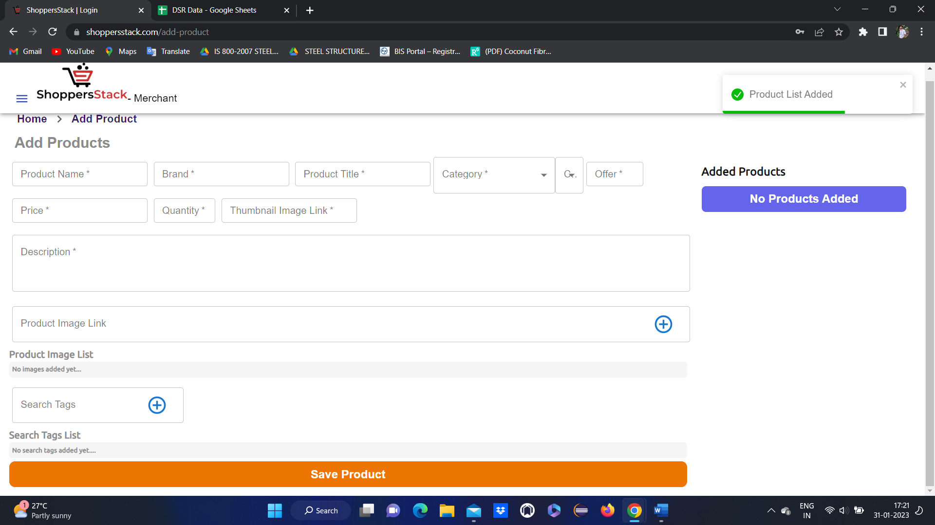

After adding the product in merchant home page product will display

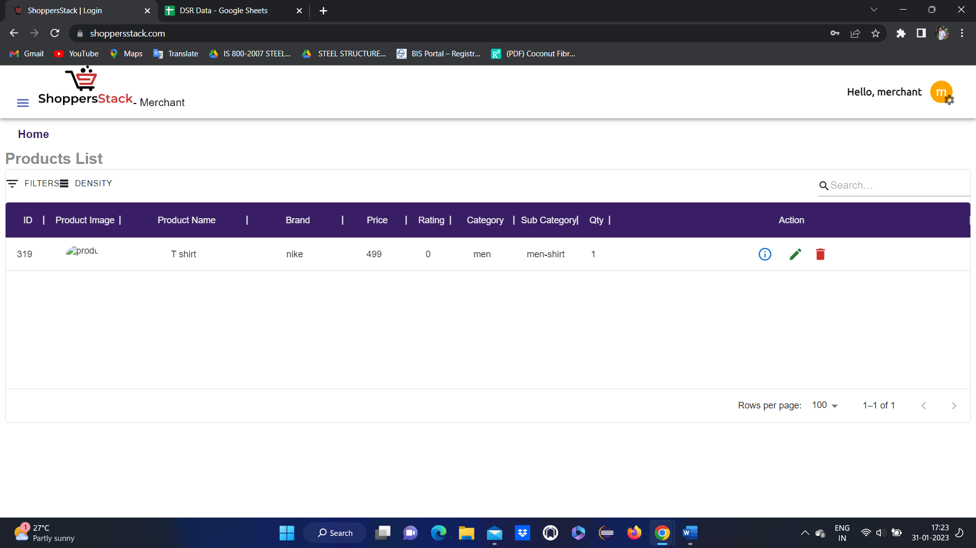

**Merchant** can

get Info about the product

edit the product

delete the product

merchant can view the account

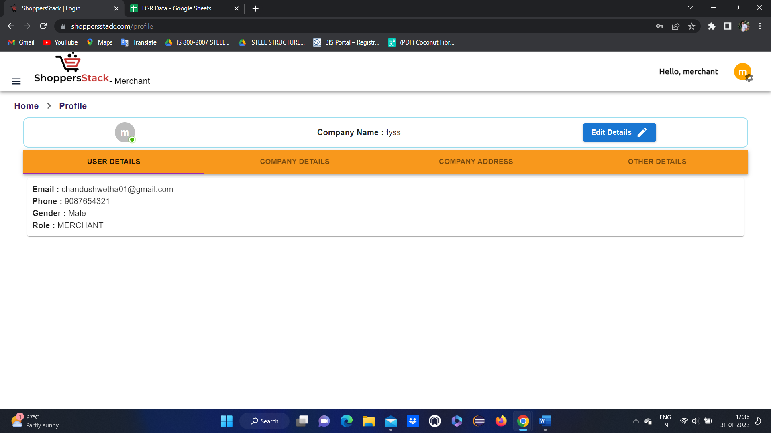

Merchant can do any changes through edit details

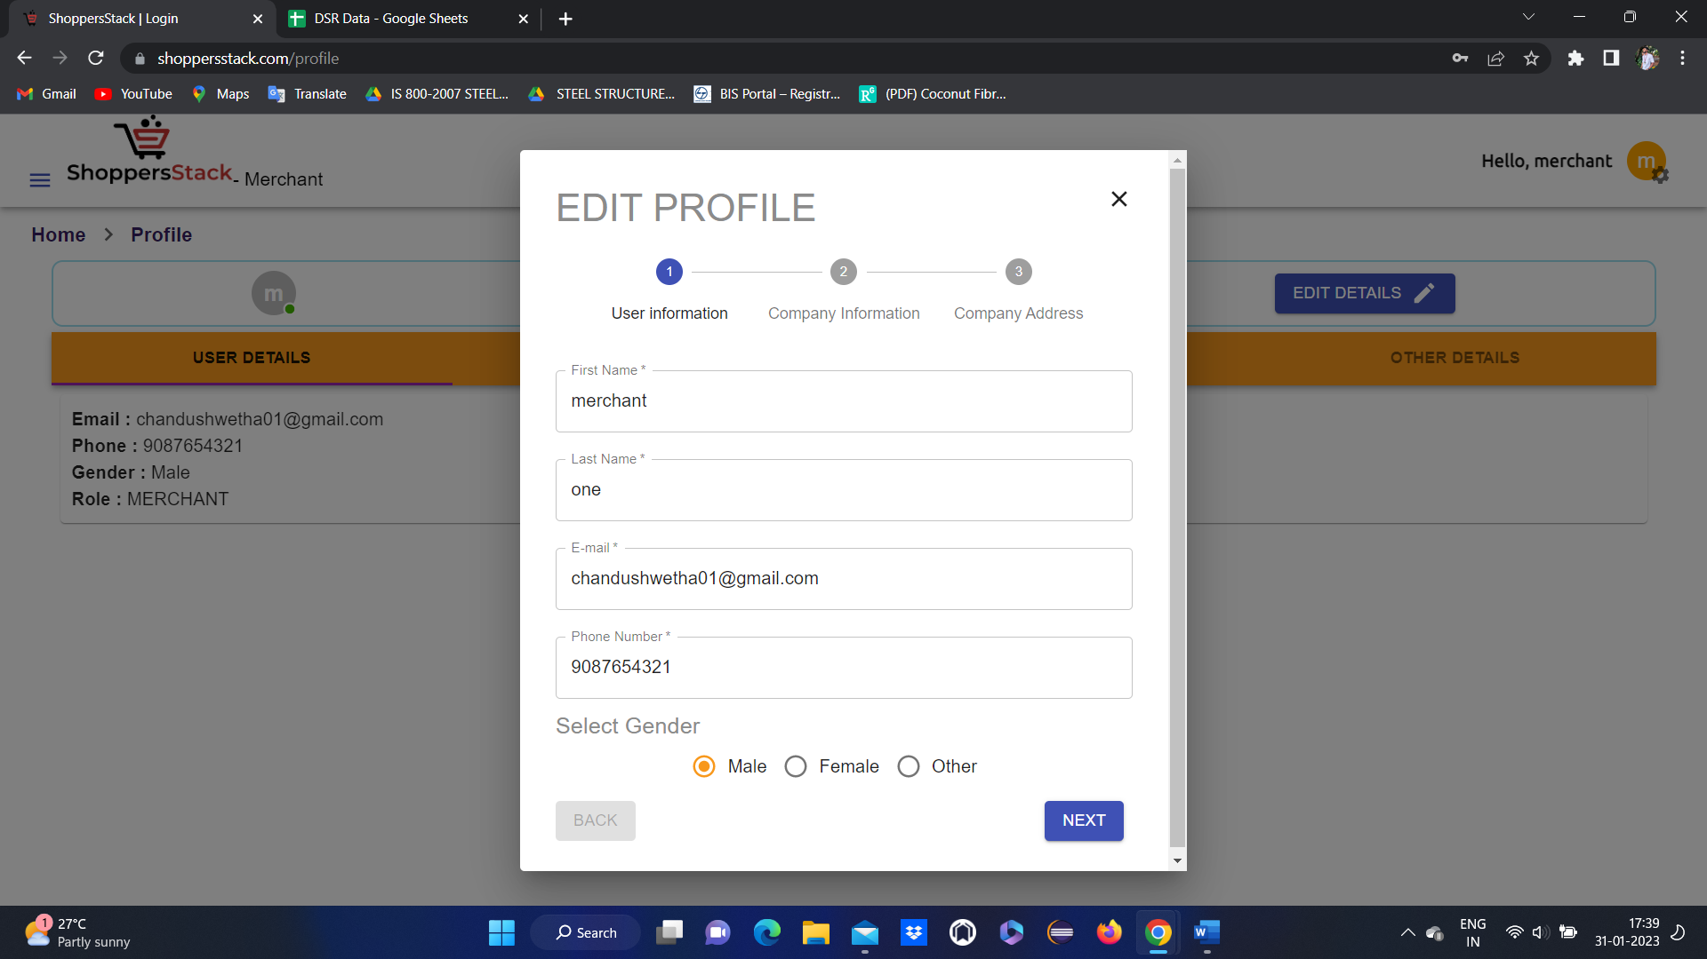

After editing the profile, the merchant should click on the finish button profile should be updated.

If a merchant wants to log out click on the settings button and click on the logout button, the merchant should log out successfully and the welcome page should be displayed.



**Admin’s Login:**

* When a user opens the browser enters the URL(https://www.shoppersstack.com/), the Home page/ Landing Page will be displayed.





* When users click on login, they will get 3 different modules: Shopper login, Merchant login & Admin login.
* When a user clicks on Admin login it should display the Admin login page & parallelly it will display Login & create account button.

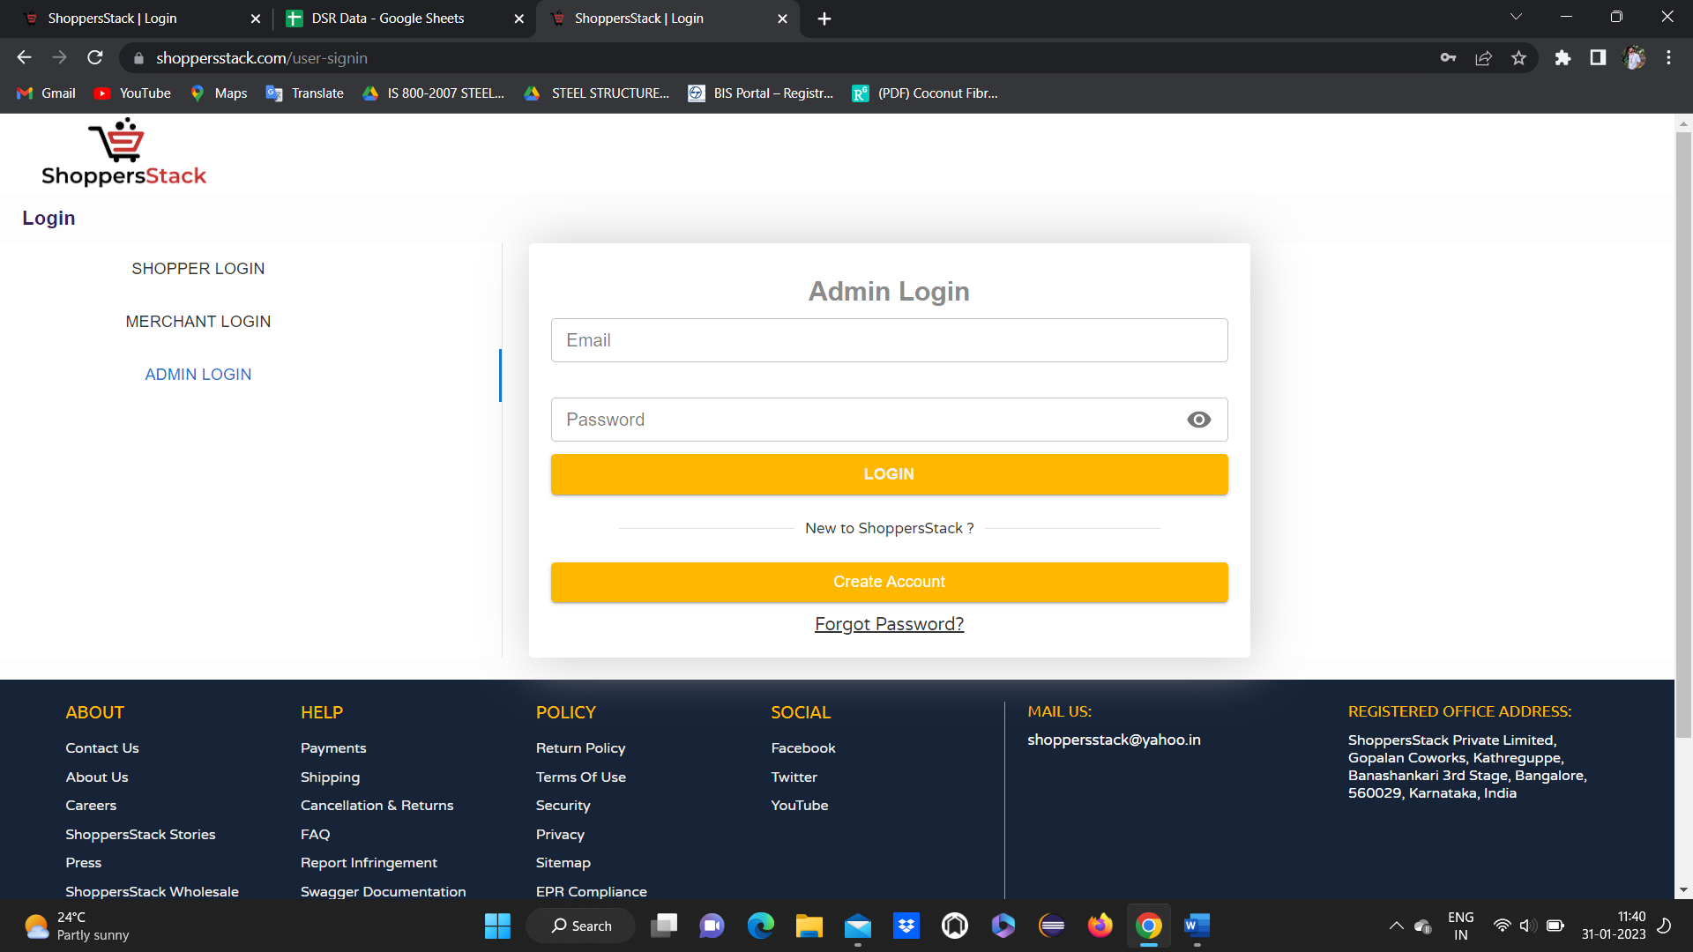

* If the user does not create the account as an admin they can’t able to log in as an admin so first, they want to click on create account button.

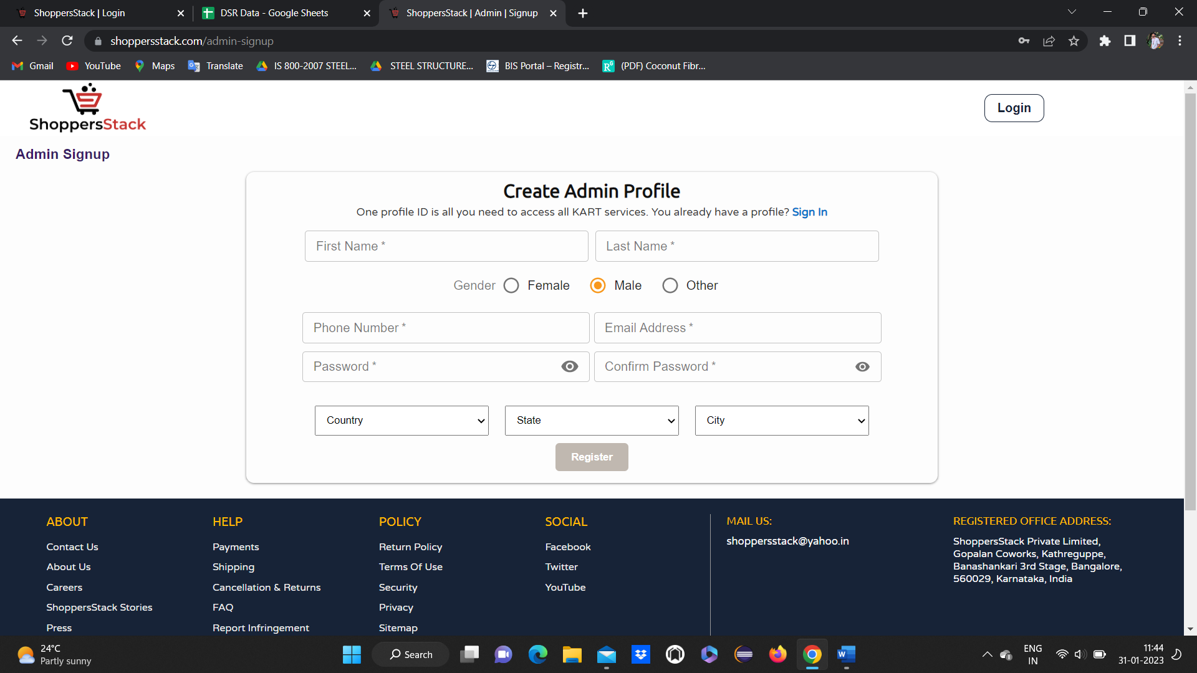

* If user click on create account create admin account page will display.
* If user enters valid data for all the mandatory fields(first name , last name ,phone number ,email , password etc) and click on register account will be successfully created and confirmation message will display stating “Profile created successfully”.
* And goto home page.

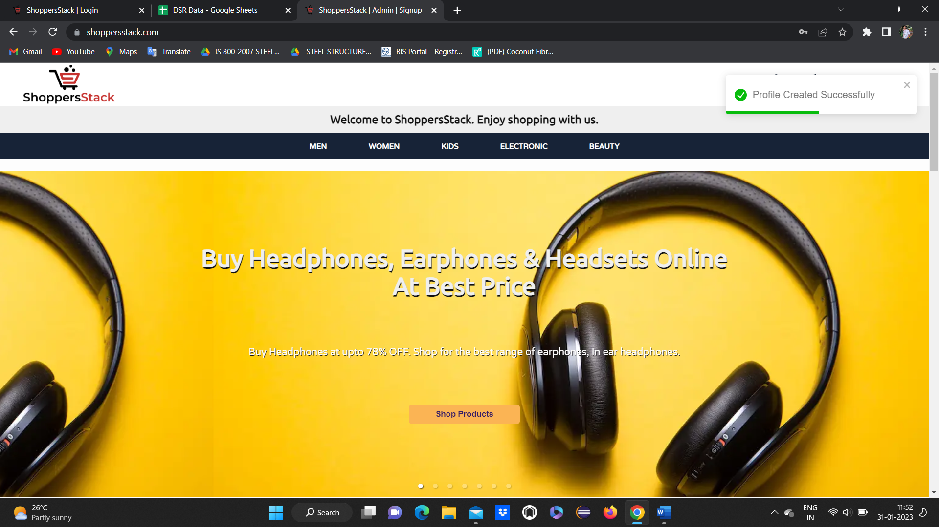

* click on Login
* click on admin login
* enter valid data (which is created) and click on login

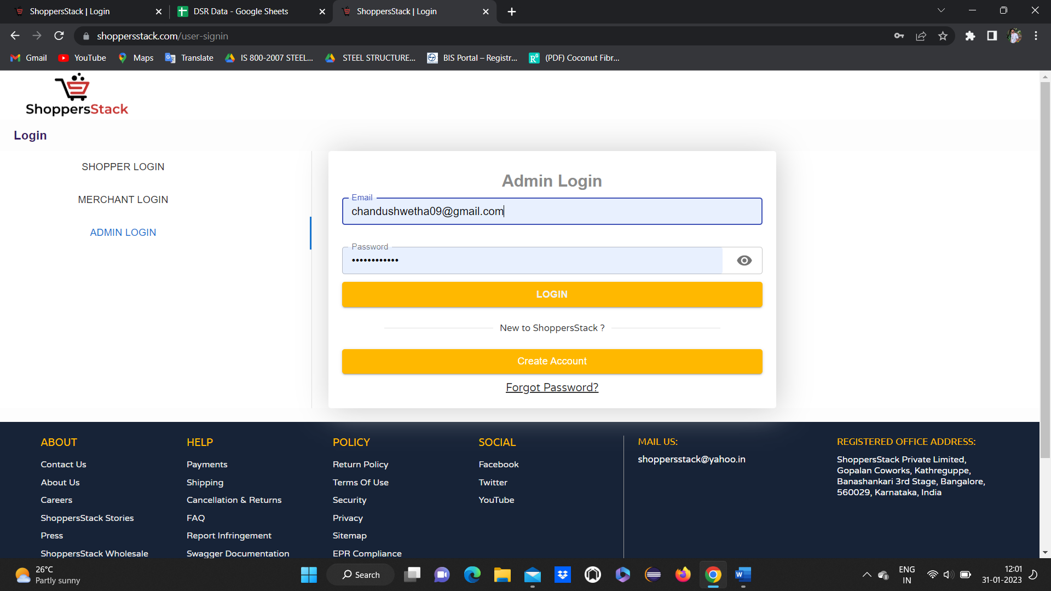

* Admin home page will be displayed.

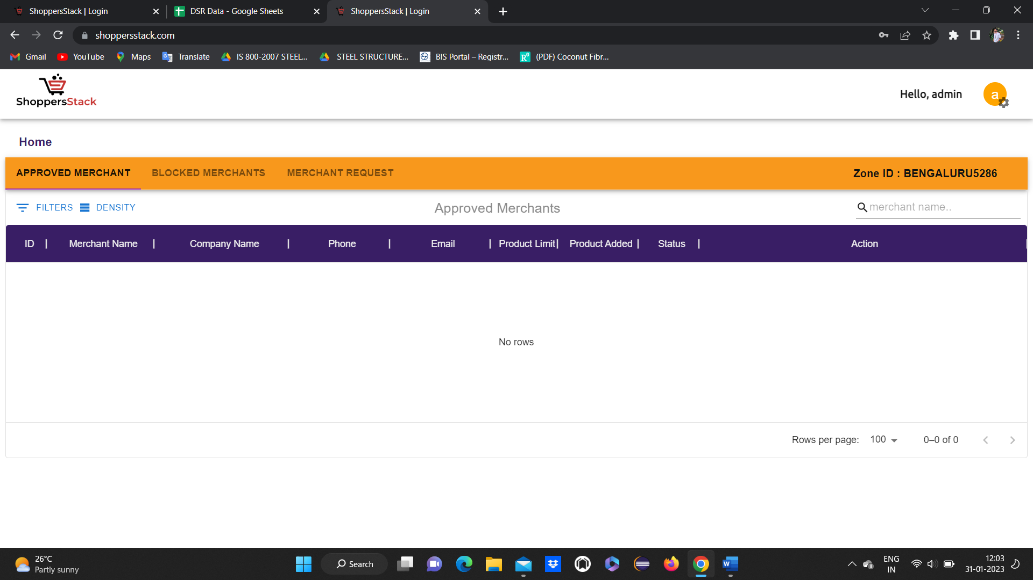

* also displays the modules like Approved merchant, Blocked merchant & Merchant request.
* If user clicks on **approved merchant**

all the approved merchant lists should be displayed in the approved merchant feature.

Admin can see complete details about the merchant like name, company name, phone no, product limit, and product added & also they can block the merchant.

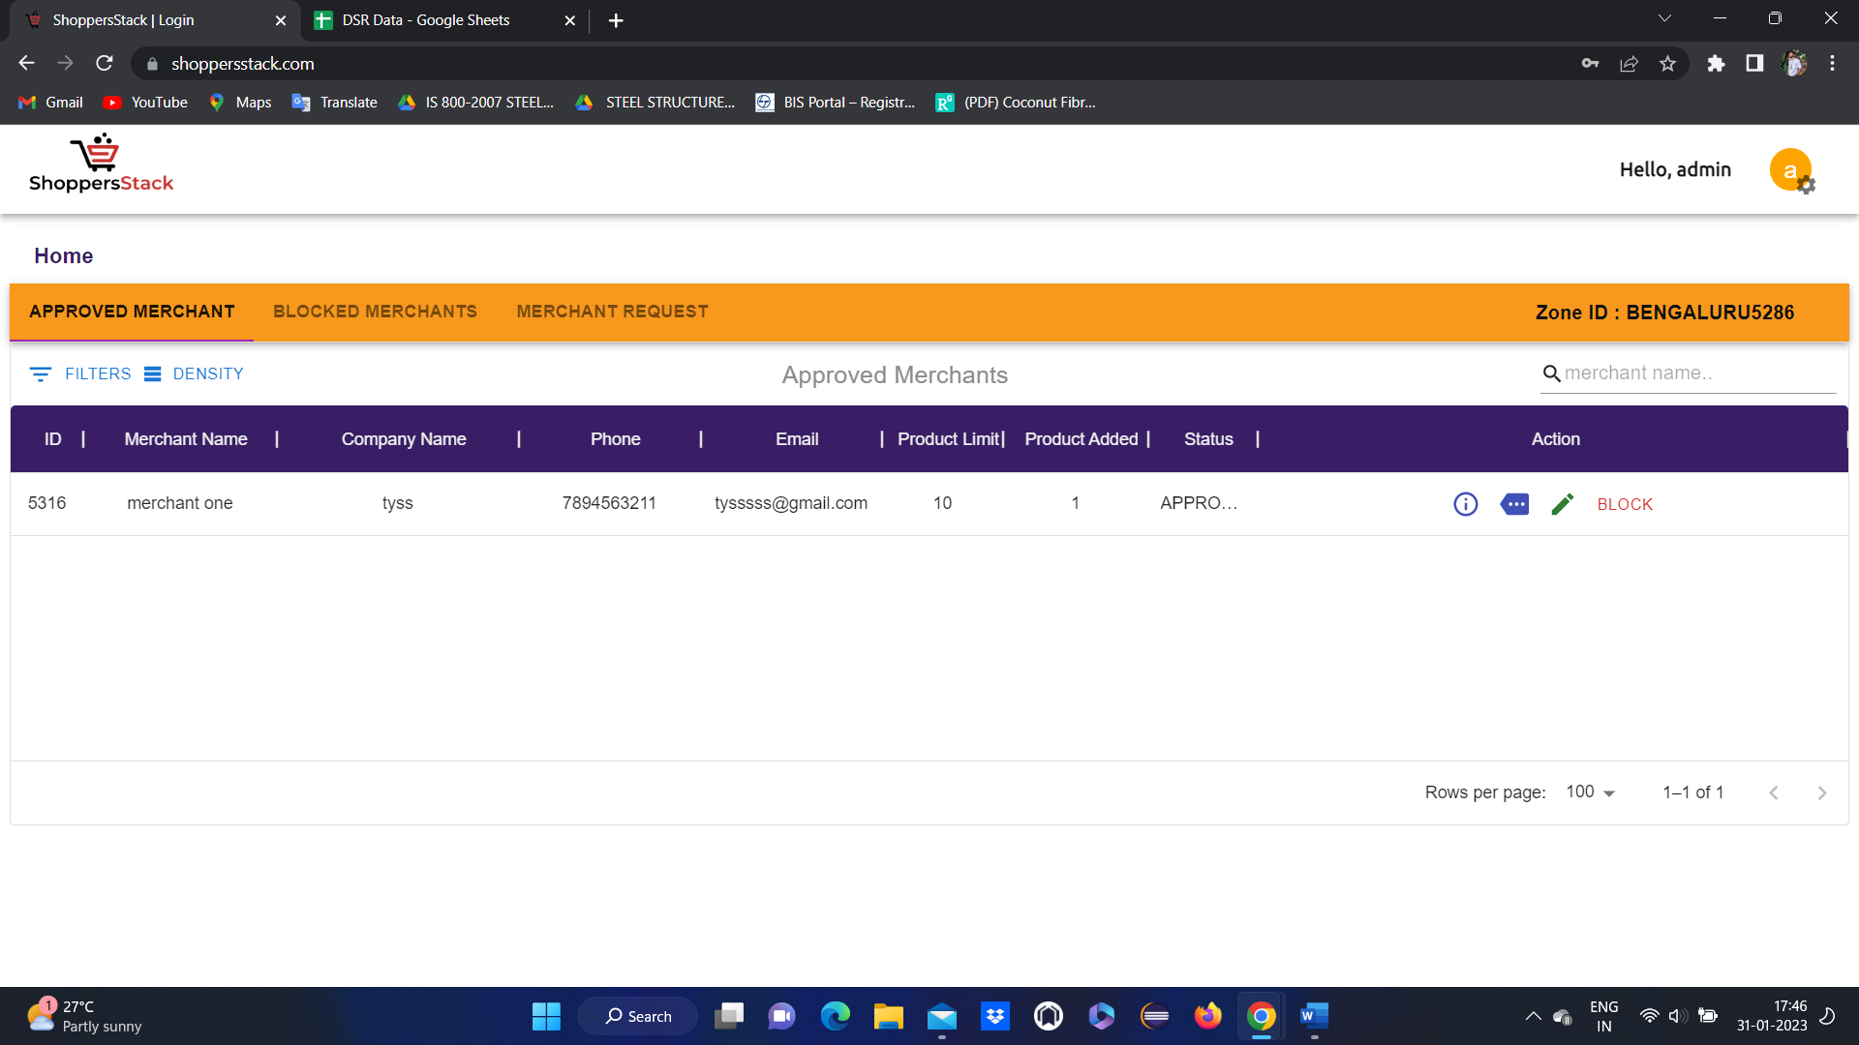

Here admin can block the merchant

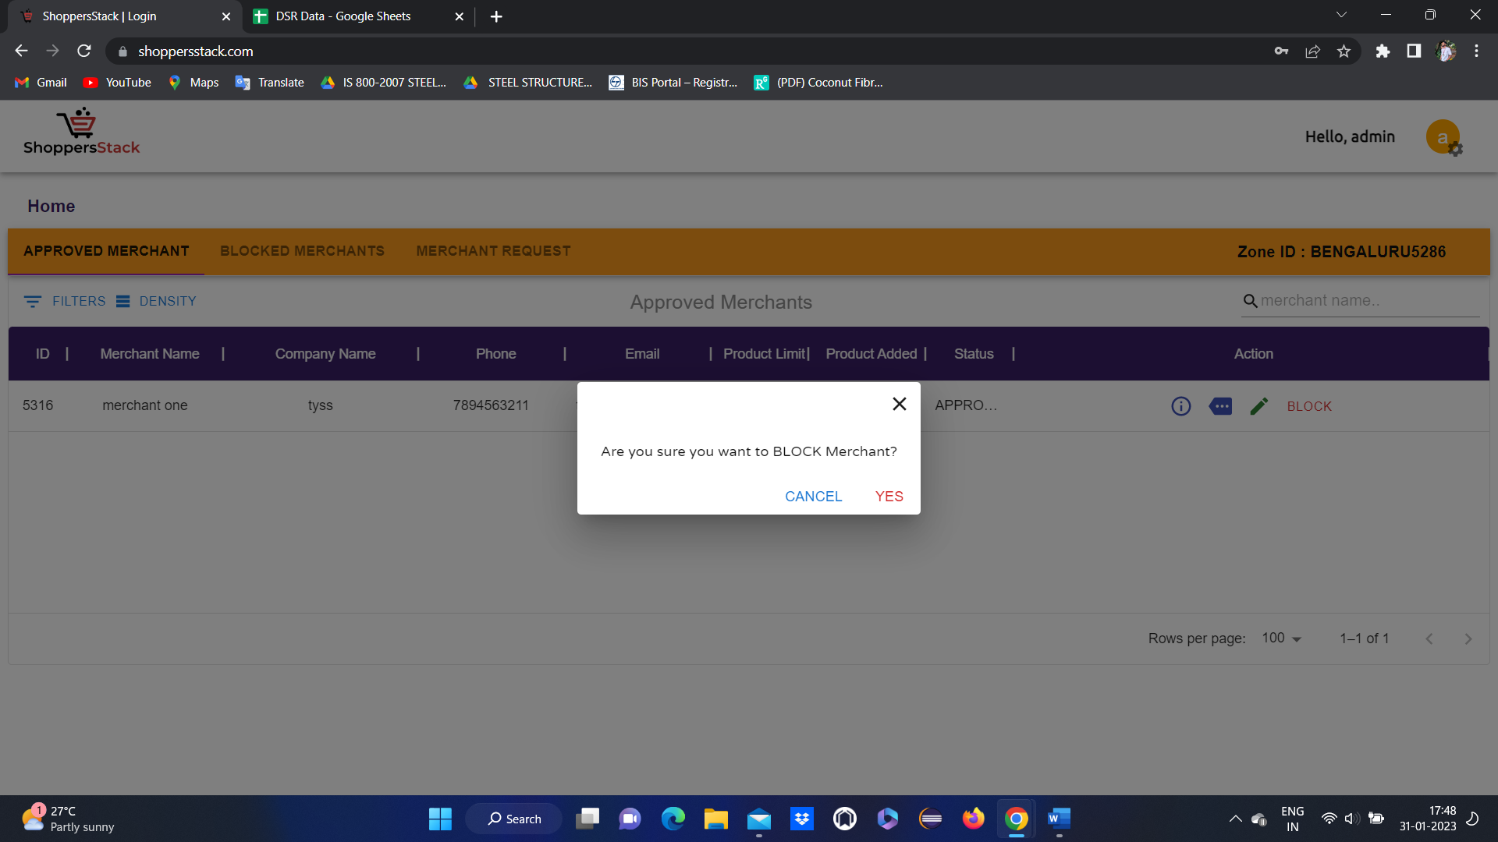

* Click on YES merchant will be blocked and provide confirmation message stating **merchant blocked**.
* If admin wants to unblock means click on **blocked merchants** and click on unblock.

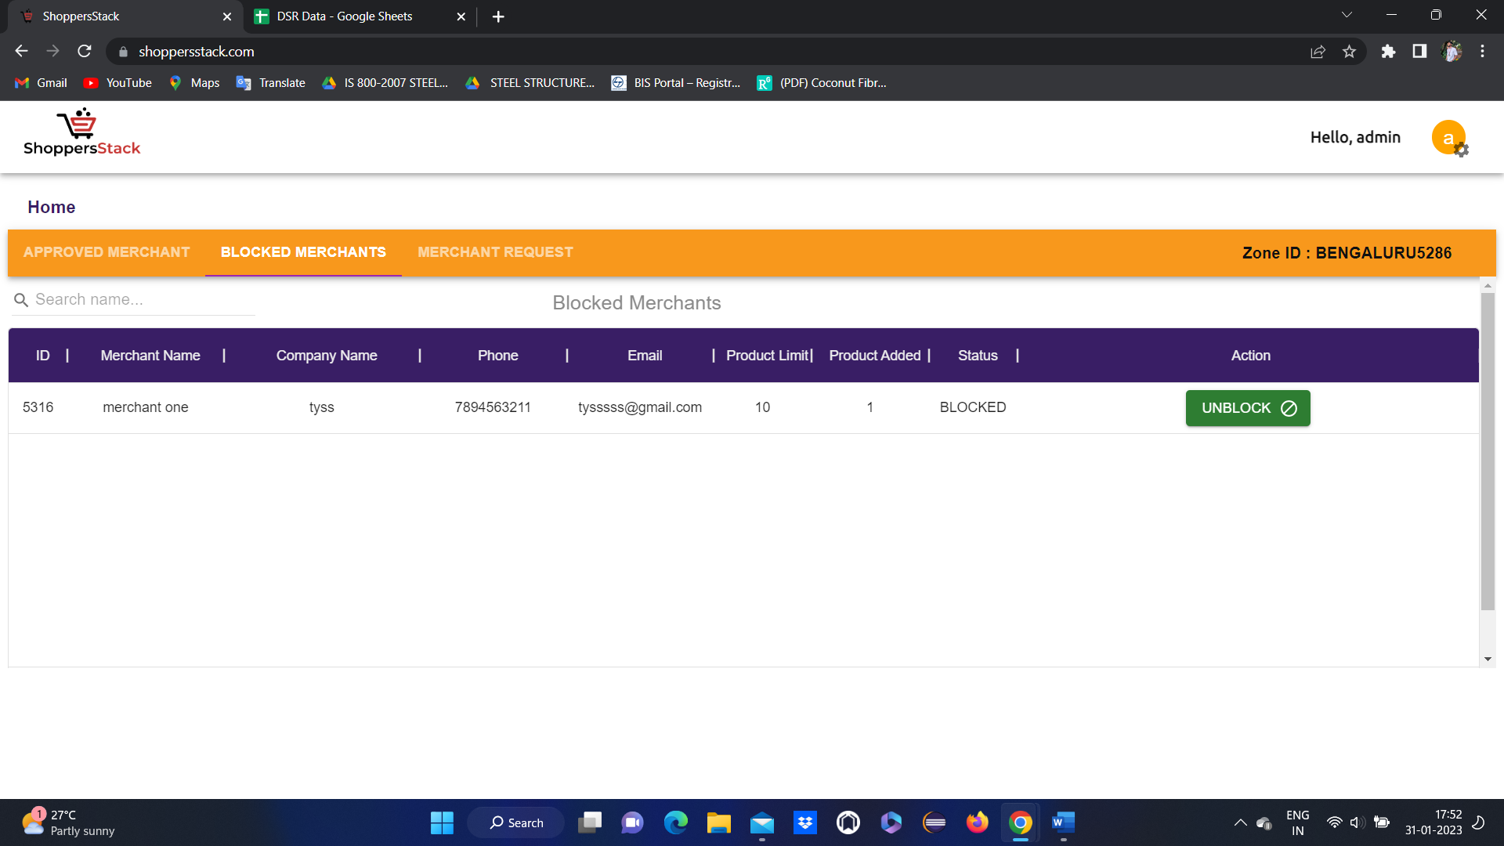

When the admin clicks on a **Merchant request** it will display a list of merchants.

When the admin is satisfied with the merchant profile, they can approve it.

When the admin clicks on approve button Merchant popup message (merchant active) will be displayed

And empty merchant page will display.

